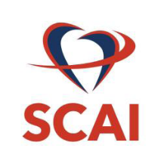

Case Submission Guidelines

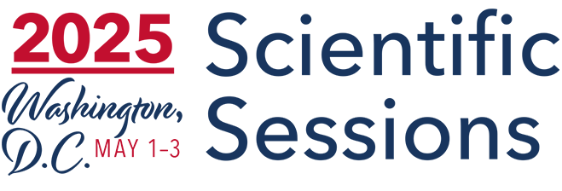

Important Dates
Case submission site opens | Tuesday, November 18, 2025
Case submission deadline | Wednesday, January 7, 2026
Case decision date | Tuesday, February 10, 2026
Case withdrawal deadline | Tuesday, February 24, 2026

Formatting
- Word limit: There is a limit of 500 words, including section headers, but not including spaces.
- Format: Cases must contain the following 4 sections: Title, Introduction, Clinical Case, and Discussion.
- Authorship: There is no limit on the number of authors; however, all authors should satisfy the ICMJE authorship criteria. Group names are not permitted, SCAI only allows individual names.
- Figures/Tables: Images are not allowed in the case report; however Case submissions also require a PPT file. The PPT can contain images, videos and text.

Policies
- Where authors use generative artificial intelligence (AI) and AI-assisted technologies in the writing process, authors should use these technologies only to improve readability and language. The technology should be applied with human oversight and control, and authors should carefully review and edit the result, as AI can generate authoritative-sounding output that can be incorrect, incomplete, or biased.
- The SCAI Program Committee endorses the position of the American Association for the Advancement for Science (AAAS) in requiring assurances of the responsible use of animals in research as well as the ethical principles outlined in the World Medical Association (WMA) Declaration of Helsinki for human medical research. All submissions for consideration must follow these guidelines.
- Case submissions must fit into one of the following categories:
  - Acute Coronary Syndromes & MI
  - Adut Congenital
  - Aortic Valve Interventions
  - Cardio-Oncology
  - Cardiogenic Shock
  - Complex PCI & Restenosis (Excluding Left Main & Multi-Vessel Intervention)
  - Imaging: CT, MR, and Non-Invasive Imaging
  - Intervention for Stable Ischemic Heart Disease
  - Interventional Heart Failure (Excluding Cardiogenic Shock) and Post-Transplant Care
  - Interventions for Afib
  - Intravascular Imaging (IVUS / OCT / NIR / Other) and Physiology (FFR / iFR / MR / Other)
  - Left Main & Multi-Vessel Intervention
  - Mechanical Circulatory Support (MCS)
  - Miscellaneous
  - Other Endovascular Interventions (Including AAA, Carotid, DVT, Renal Denervation and Venous Disease)
  - PAD & CLI
  - Pediatric
  - Pharmacotherapy
  - Pulmonary Artery Interventions (Including PE & PH)
  - Quality Improvement
  - Structural Heart Disease (Excluding Valvular Interventions)
  - Thrombectomy and Vulnerable Plaque
  - Valve Interventions (Excluding Aortic Valve-Interventions)
  - Vascular Access and Arterial Closure Devices

Submission, Revision, and Withdrawal
- All case submissions must be completed by the case submission deadline.
- Once a case is submitted, SCAI will communicate only with the designated presenting author.
- All case revisions must be completed by the case submission deadline. Revisions will only be accepted by the presenting author. This includes changes to author names, author order, author affiliation, and the addition or deletion of authors. SCAI is not responsible for work that is not submitted by the case submission deadline.
- Cases may be withdrawn by the case withdrawal deadline.
- Requests to withdraw a case must be submitted in writing to cases@scai.org by the presenting author by the case withdrawal deadline

